1_JOINS  
INNER JOIN

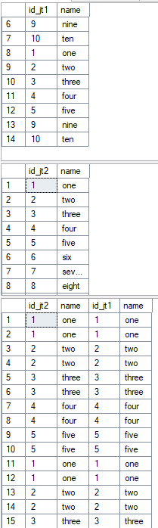

LEFT OUTER JOIN, RIGHT OUTER JOIN

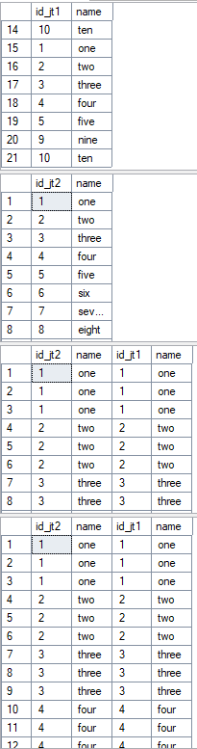

FULL OUTER JOIN

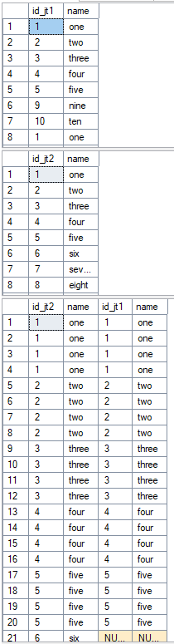

CROSS JOIN

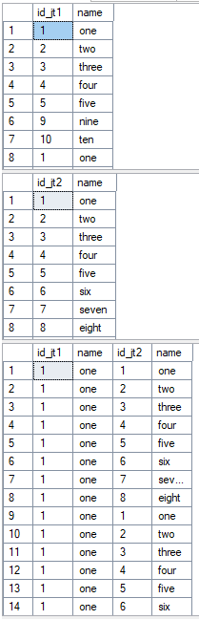

2_UNION_EXCEPT_INTERSECT

UNION

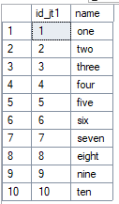

UNION ALL

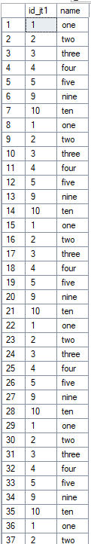

EXCEPT

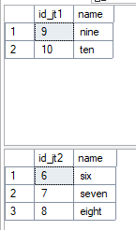

INTERSECT

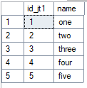

3_CerateShopDB

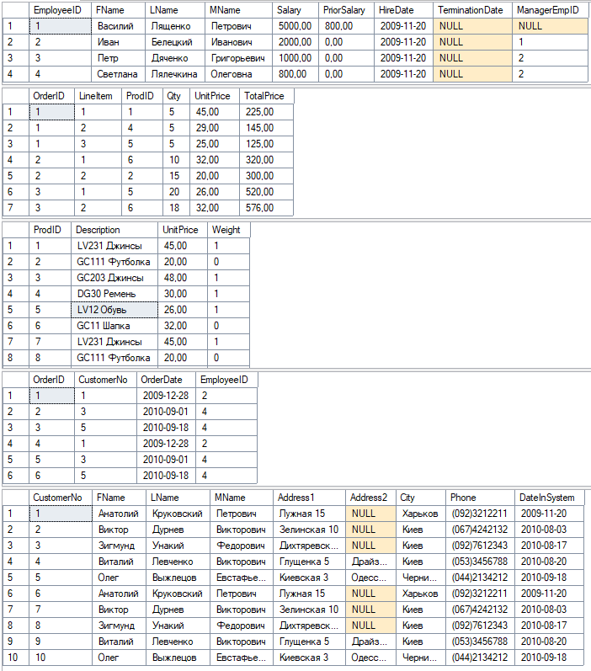

4_JOINS_Practice

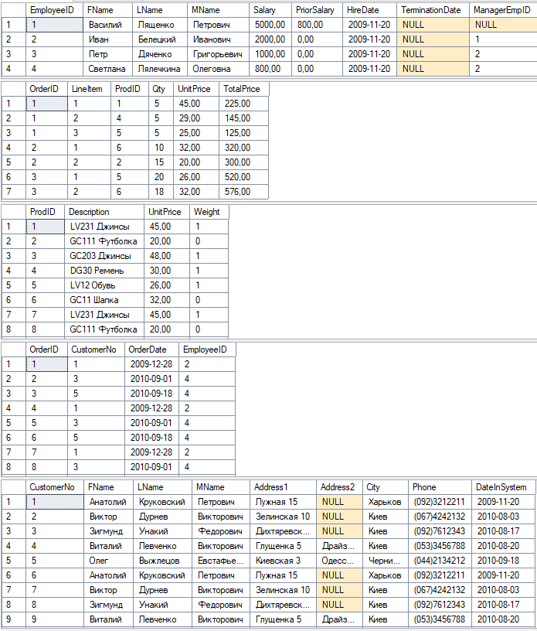

5_ClassWork

